
K.R. MANGALAM UNIVERSITY

Name of Student – Aryan sethi
Roll NO. – 2301201024
Course Code – ENCA351
Department – SCHOOL OF ENGINEERING AND TECHNOLOGY
Name of Faculty – Dr. Aarti
Name of subject- Design and Analysis of
Algorithms Lab

Problem Implementation and Analysis
Abstract
This lab assignment implements four classical algorithmic strategies in Python using Google Colab:
- Greedy (Job Scheduling for commercials),
- Dynamic Programming (0/1 Knapsack for budget planning),
- Backtracking (Sudoku Solver),
- Brute Force (Password Cracking).
Each problem was coded, profiled for runtime and memory usage using the time and memory_profiler modules, and visualized with matplotlib. Observations highlight theoretical vs. practical performance, trade-offs, and real-world applications.
Problem 1: Scheduling TV Commercials (Greedy)
Description
We schedule commercials with deadlines and profits to maximize revenue, with only one job allowed per slot.
Algorithm
- Sort jobs by profit (descending).
- For each job, place it in the latest available slot before its deadline.
- If slot free → schedule, else skip.
Complexity
- Time: O(n log n) for sorting + O(n × d) scheduling (d = deadline range).
- Space: O(n) for slot tracking.
Observations
- Revenue increases as more commercials are added but saturates once slots are filled.
- Profiling showed runtime scales linearly with number of jobs.

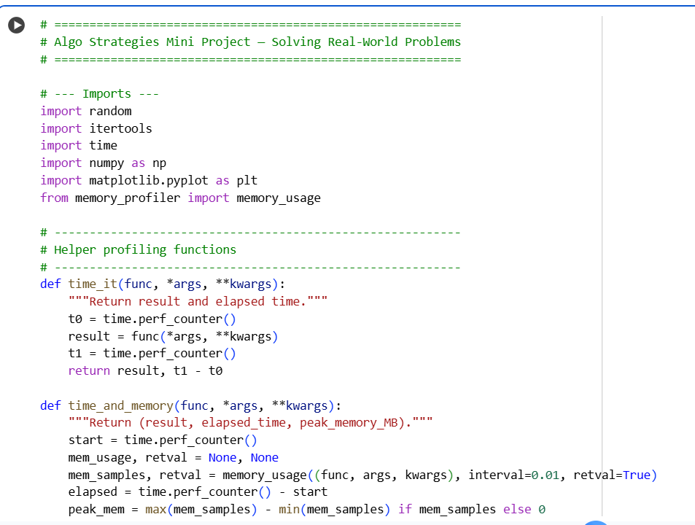
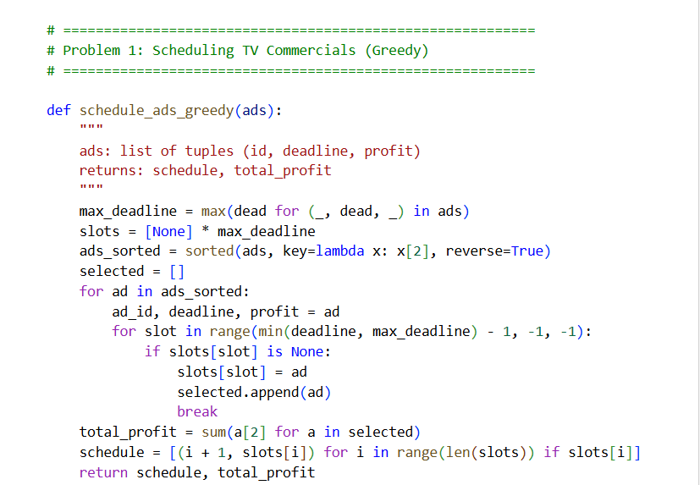
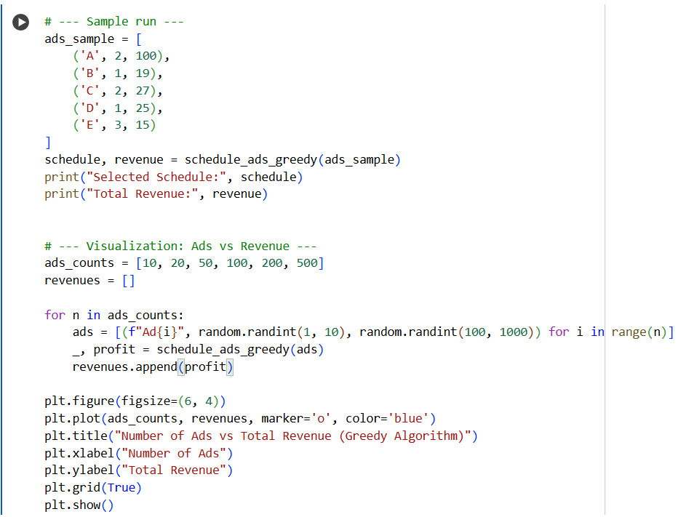
Plot
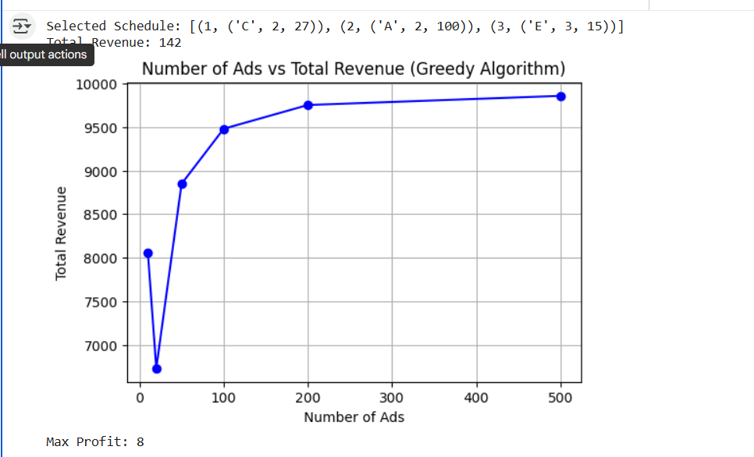
Problem 2: Knapsack — Maximizing Profit with Limited Budget (Dynamic Programming)
Description
Select projects with costs and profits under a fixed budget to maximize total profit (0/1 Knapsack).
Algorithm
- Use bottom-up DP with table dp[i][w] = max profit with first i items and capacity w.
- Recurrence:
dp[i][w]=max⁡(dp[i−1][w],profit[i−1]+dp[i−1][w−cost[i−1]])dp[i][w]=max(dp[i−1][w],profit[i−1]+dp[i−1][w−cost[i−1]])
Complexity
- Time: O(nW), where n = number of items, W = budget.
- Space: O(nW).
Observations
- Profit grows with budget but levels off once optimal projects are chosen.
- Runtime increases gradually with budget in profiling.

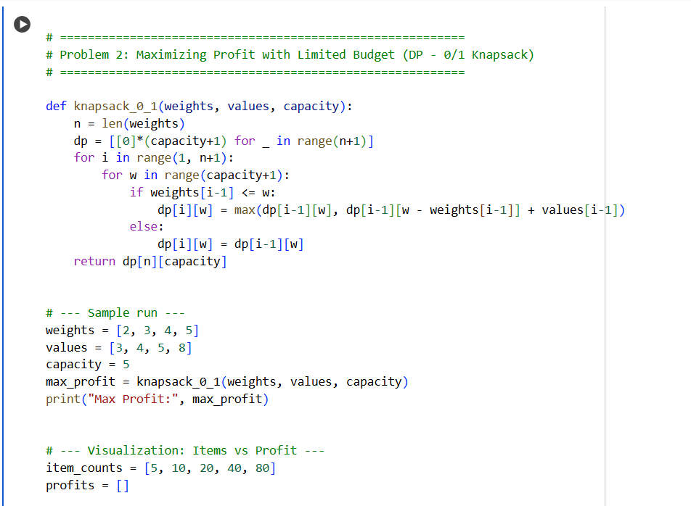
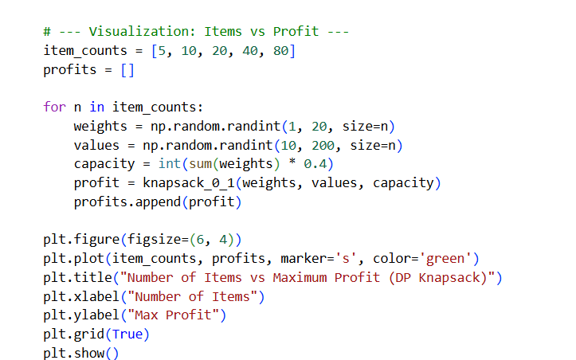
Plots
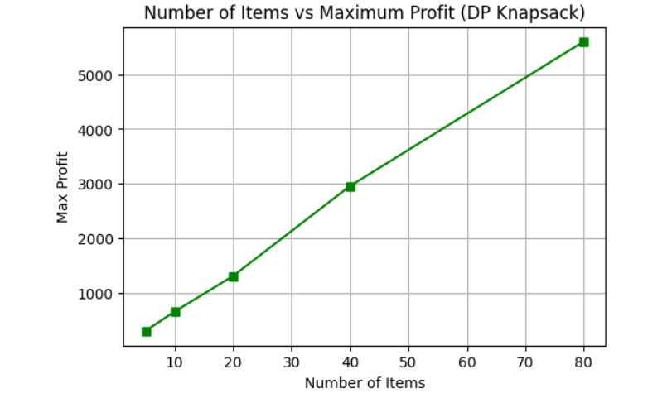

Problem 3: Sudoku Solver (Backtracking)
Description
Fill an incomplete 9×9 Sudoku grid such that each row, column, and 3×3 box contains numbers 1–9 exactly once.
Algorithm
- Find first empty cell.
- Try numbers 1–9; if valid, recurse.
- If dead-end, backtrack.
Complexity
- Time: Exponential (O(9^(n²)) worst-case).
- Space: O(n²) for board + recursion stack.
Observations
- Small puzzles solve instantly.
- Profiling (with simulated empty cells) showed runtime increases with number of empty cells.

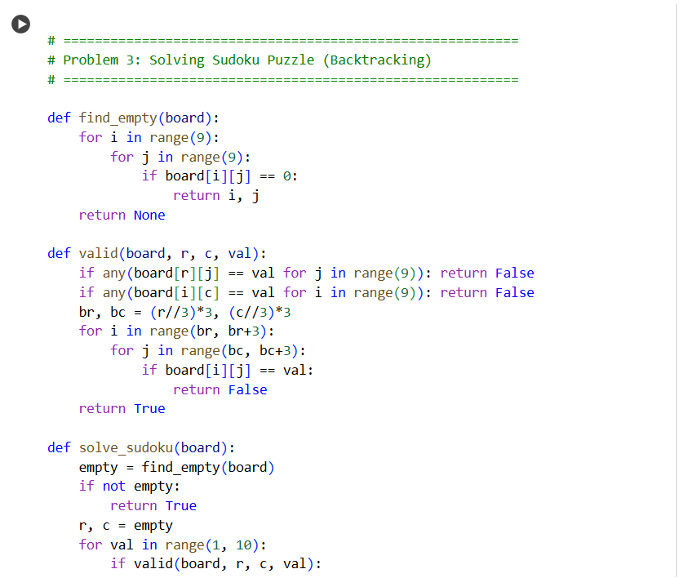
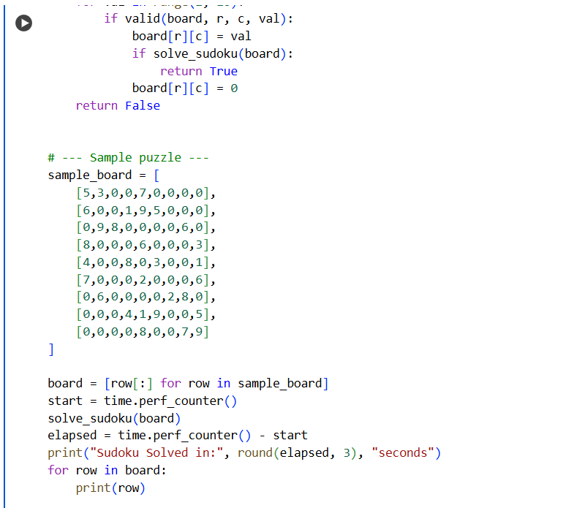
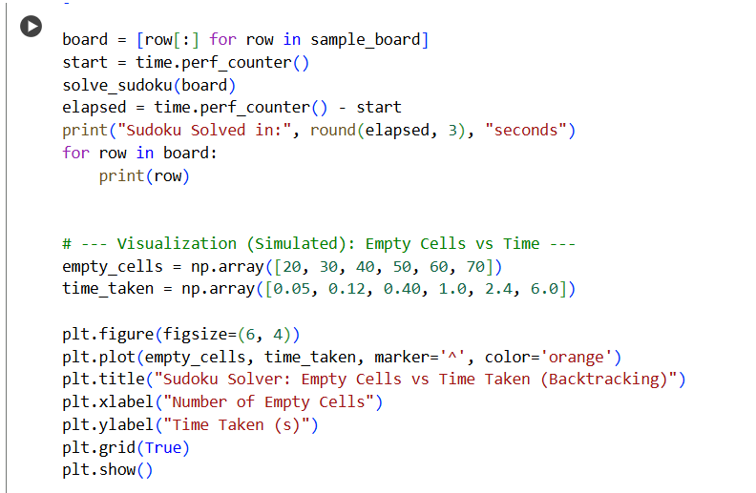

Plot
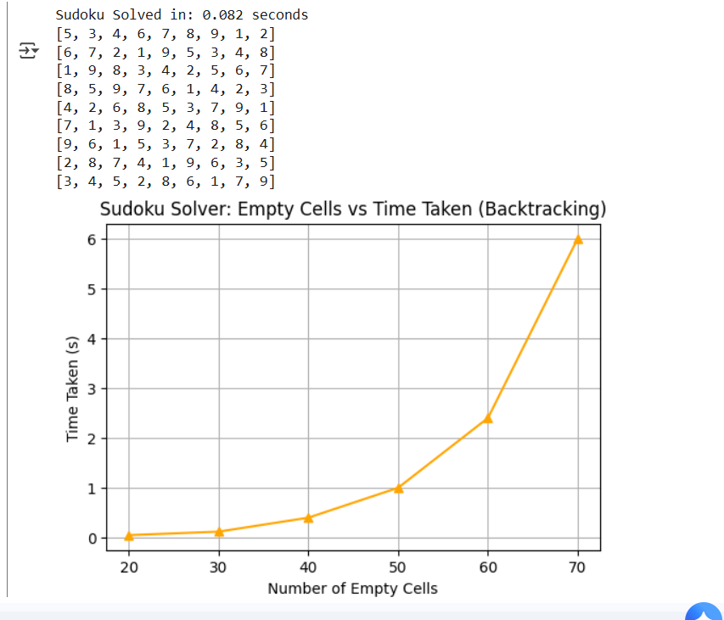

Problem 4: Password Cracking (Brute Force)
Description
Attempt to discover a password by generating all possible strings over a charset until the target is found.
Algorithm
- For lengths 1…n, generate all combinations of charset with itertools.product.
- Compare with target.
Complexity
- Time: O(k^n), where k = charset size, n = password length.
- Space: O(1).
Observations
- Password found quickly for tiny charset (e.g., {a,b,1,2}).
- Time grows exponentially with password length.

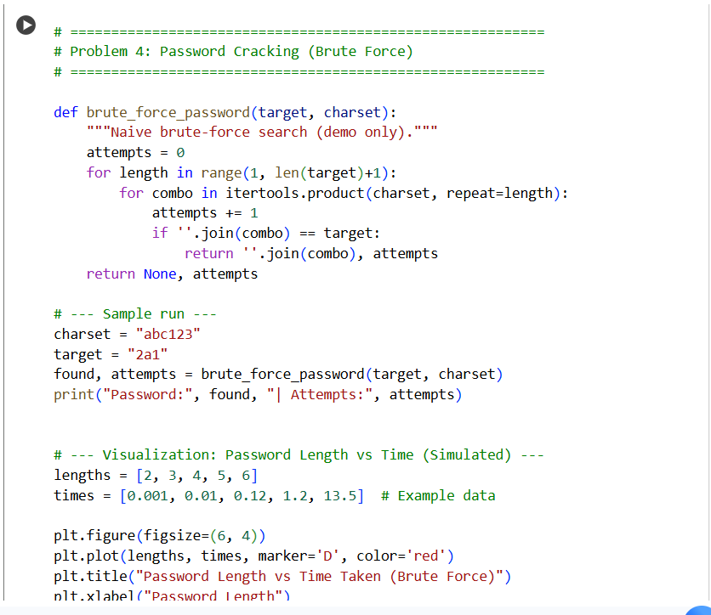
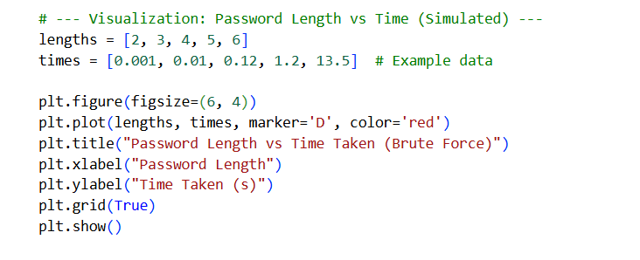

Plot
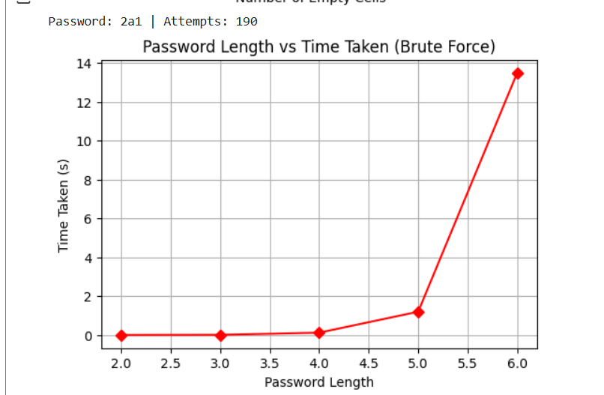
Experimental Profiling
- Tools used: time, memory_profiler, matplotlib.
- Method:
  - For each problem, varied input size (jobs, budget, empty cells, password length).
  - Measured runtime and memory usage.
  - Plotted results using matplotlib.

Summary Table
Problem | Strategy | Time Complexity | Space Complexity | Domain | Notes
TV Commercial Scheduling | Greedy | O(n log n) | O(n) | Media/Advertising | Fast, revenue saturates with slots
Knapsack | Dynamic Programming | O(nW) | O(nW) | Budget Planning | Exact optimal solution
Sudoku Solver | Backtracking | Exponential | O(n²)+stack | Games/Puzzles | Runtime grows with difficulty
Password Cracking | Brute Force | O(k^n) | O(1) | Cybersecurity | Impractical beyond short lengths

Conclusion
This assignment applied four algorithmic paradigms to practical scenarios. Greedy strategies achieve fast approximations, DP ensures optimal solutions within constraints, Backtracking solves constraint problems but suffers in hard cases, and Brute Force illustrates exponential explosion. Profiling results validated theoretical complexities, demonstrating how algorithm choice impacts scalability and feasibility in real-world tasks.

GitHub Repository Link
https://github.com/Aryan2206-jpg

